**File Structure - Interim POS** 

Contained within is a general guideline on the file structure of Interim-POS.

Admin: Contains all admin-related files.

Css: Contains all style sheets

Fonts: Contains all fonts

Img: Contains all images

Includes: Assuming Professor wants us to keep PHP here

JS: Contains all JavaScript files

Np: Contains documentation of NewPaltz-related items such as flowcharts. Subfolders are one per member of the team.

Jennie :

SQL : Jennie’s SQL folder should contain the SQL code for the database

Naming Convention:

This is open to change, but I believe that a suitable naming convention is as follows:

COMPONENT_SPECIFIER.FILETYPE

For example, if the landing page needs a separate login page, the names of the pages would be as follows.

landingPage.php

landingPage_login.php

This allows us to assume the file with no specifiers is the main page and that the specifiers are pages to be navigated to.

**GitHub Guidelines - Interim POS  
**

Contained within is a general guideline on how GitHub will be used.

**To upload code to GitHub:**

Make a local copy before you do any of this. GitHub is a complex piece of software that is easy to make mistakes with.

**Pull :**

This will pull all external changes from the repository to your machine.



**Commit :**

Fill in the summary and description

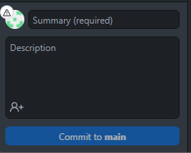

**Push :**

Add the committed changes to the repository

